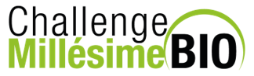

CHALLENGE MILLESIME BIO 2023 REGISTRATION PROCEDURE

I – CONNECTION TO THE ONLINE PORTAL
https://account.sudvinbio.com/
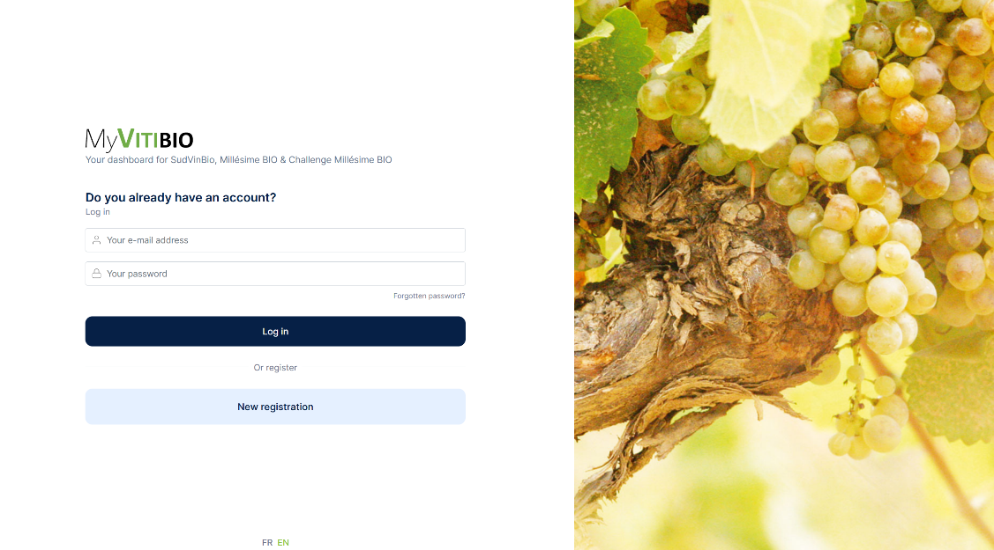

II – WELCOME TO MyVitibio
Just before accessing to the contest registration, you need to answer to the 3 questions pointed by red arrows, in the « Challenge Millésime Bio 2023 » insert of your company

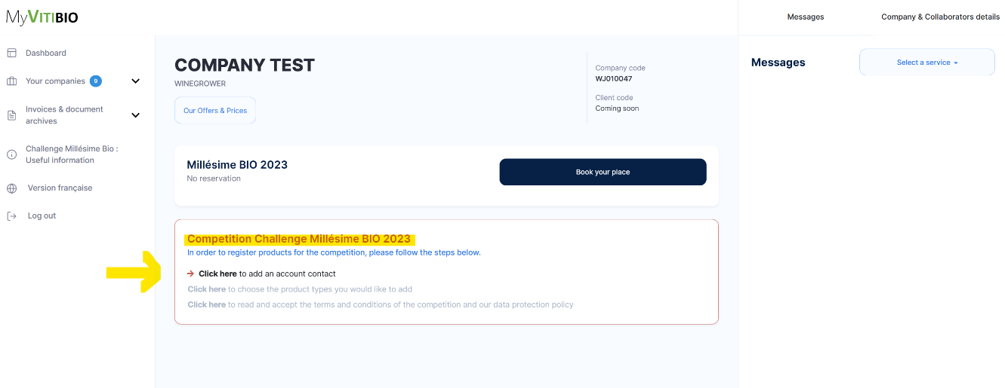

III – REGISTRATION ACCESS
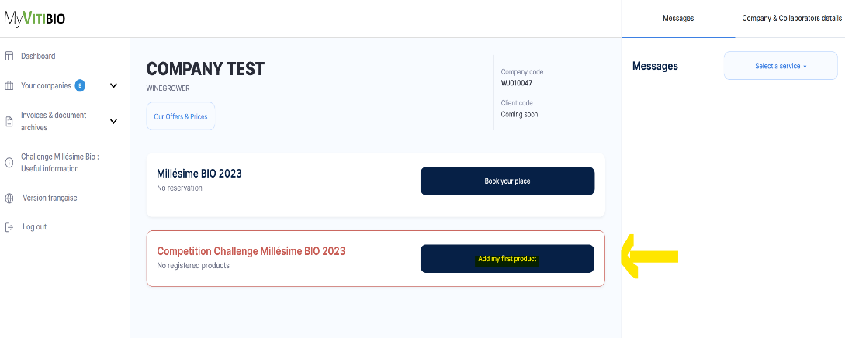
Once you answered the 3 questions, “Add my first product” will appear :

IV – REGISTER A PRODUCT
** Please note the criteria and documents required for your registration **
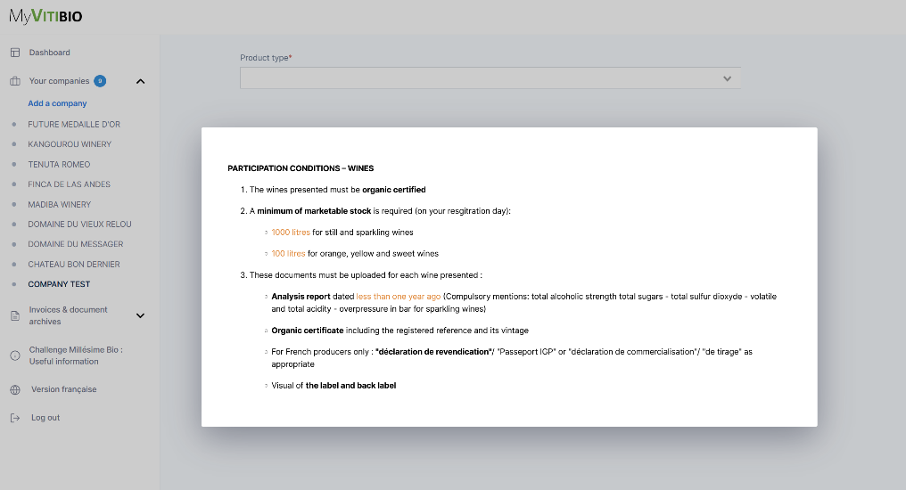
1/ After reading this list, fill in the registration form below for each product presented
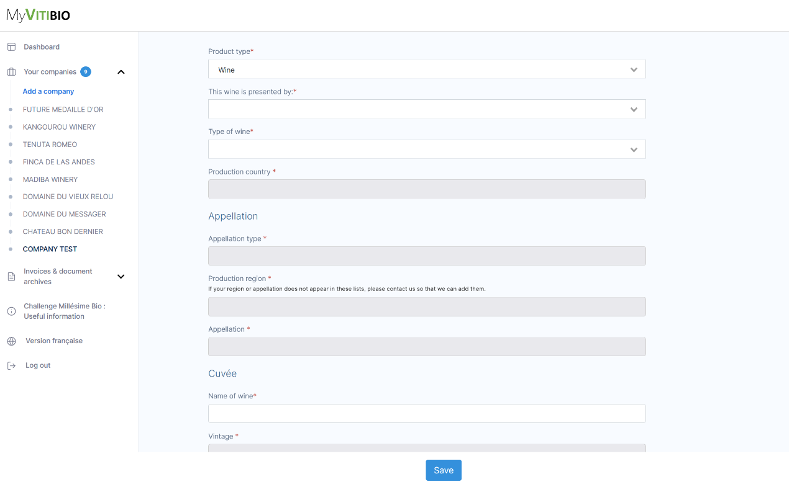

2/ FOCUS ON STOCKS : The minimum required by the National Competition Regulations for still or sparkling wines is 1000 LITERS and for sweet or orange wines is 100 LITERS
3/ Don’t forget to save your form

V – UPLOAD YOUR DOCUMENTS
NB : Please consult the list of mandatory documents by following those links :
- For wines
- For beers : Article 4 of the Rules
1/ Each document has its own location, several uploads are possible, and you will be able to do it even after clicking in « I have finished my registration »
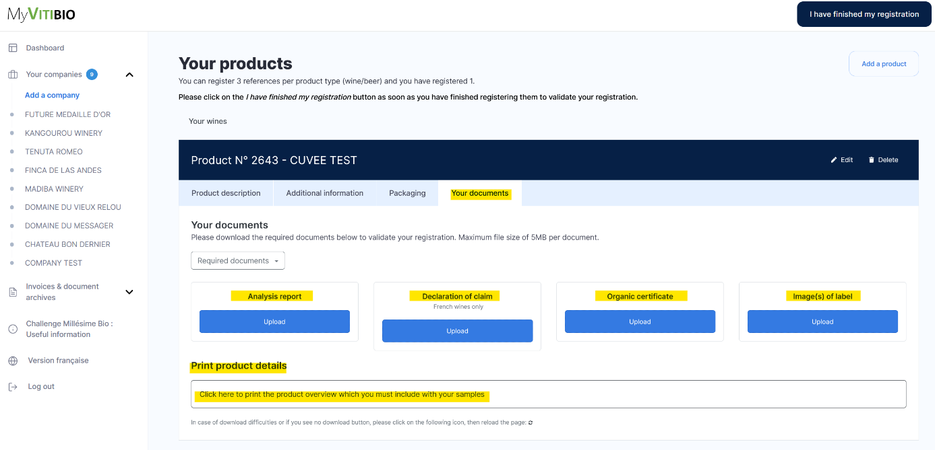

2/ Click in « Add a product » if you want to register another product (until 15 products max)
3/ Once all your products are registered and all your documents, click in « I have finished my registration »
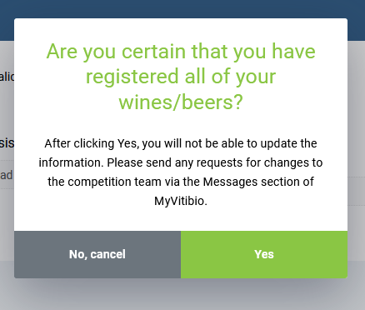
VI – FINALIZE YOUR REGISTRATION
This step is essential to your file processing, even if it is not
complete

For any modification or adding product after this click of
confirmation, you will have to contact the Challenge Millésime
Bio staff using your MyVitibio mailbox

VII – MAILBOX & PAYMENT
File tracking
& staff contact

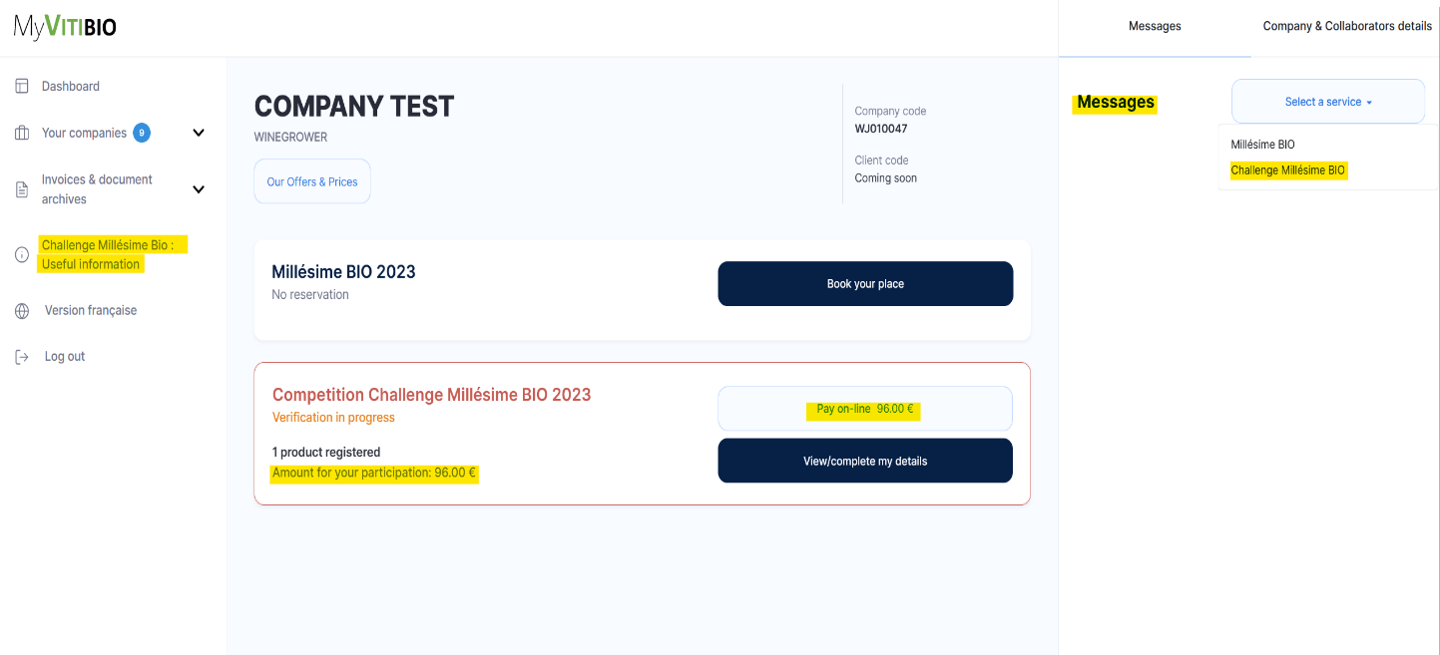

Useful info

Pay by credit card

Amount due

1/ Check the terms of payment in “Challenge Millésime BIO : Useful information”

2/ Billing : your invoice will be issued after payment and all your informations, documents and samples validation

